Methods of evaluation in sports
Monitoring techniques in sports
Methodology of Football Basic of football
2001 – 2008 Cluj-Napoca, Romania

PHYSICAL EDUCATION AND SPORT LECTURER BABES-BOLYAI UNIVERSITY

Teaching:
Methodology of teaching football
Methodology of Football
Basic of football

1999 – 2001 Cluj-Napoca, Romania

UNIVERSITY TEACHING ASSISTANT BABES-BOLYAI UNIVERSITY

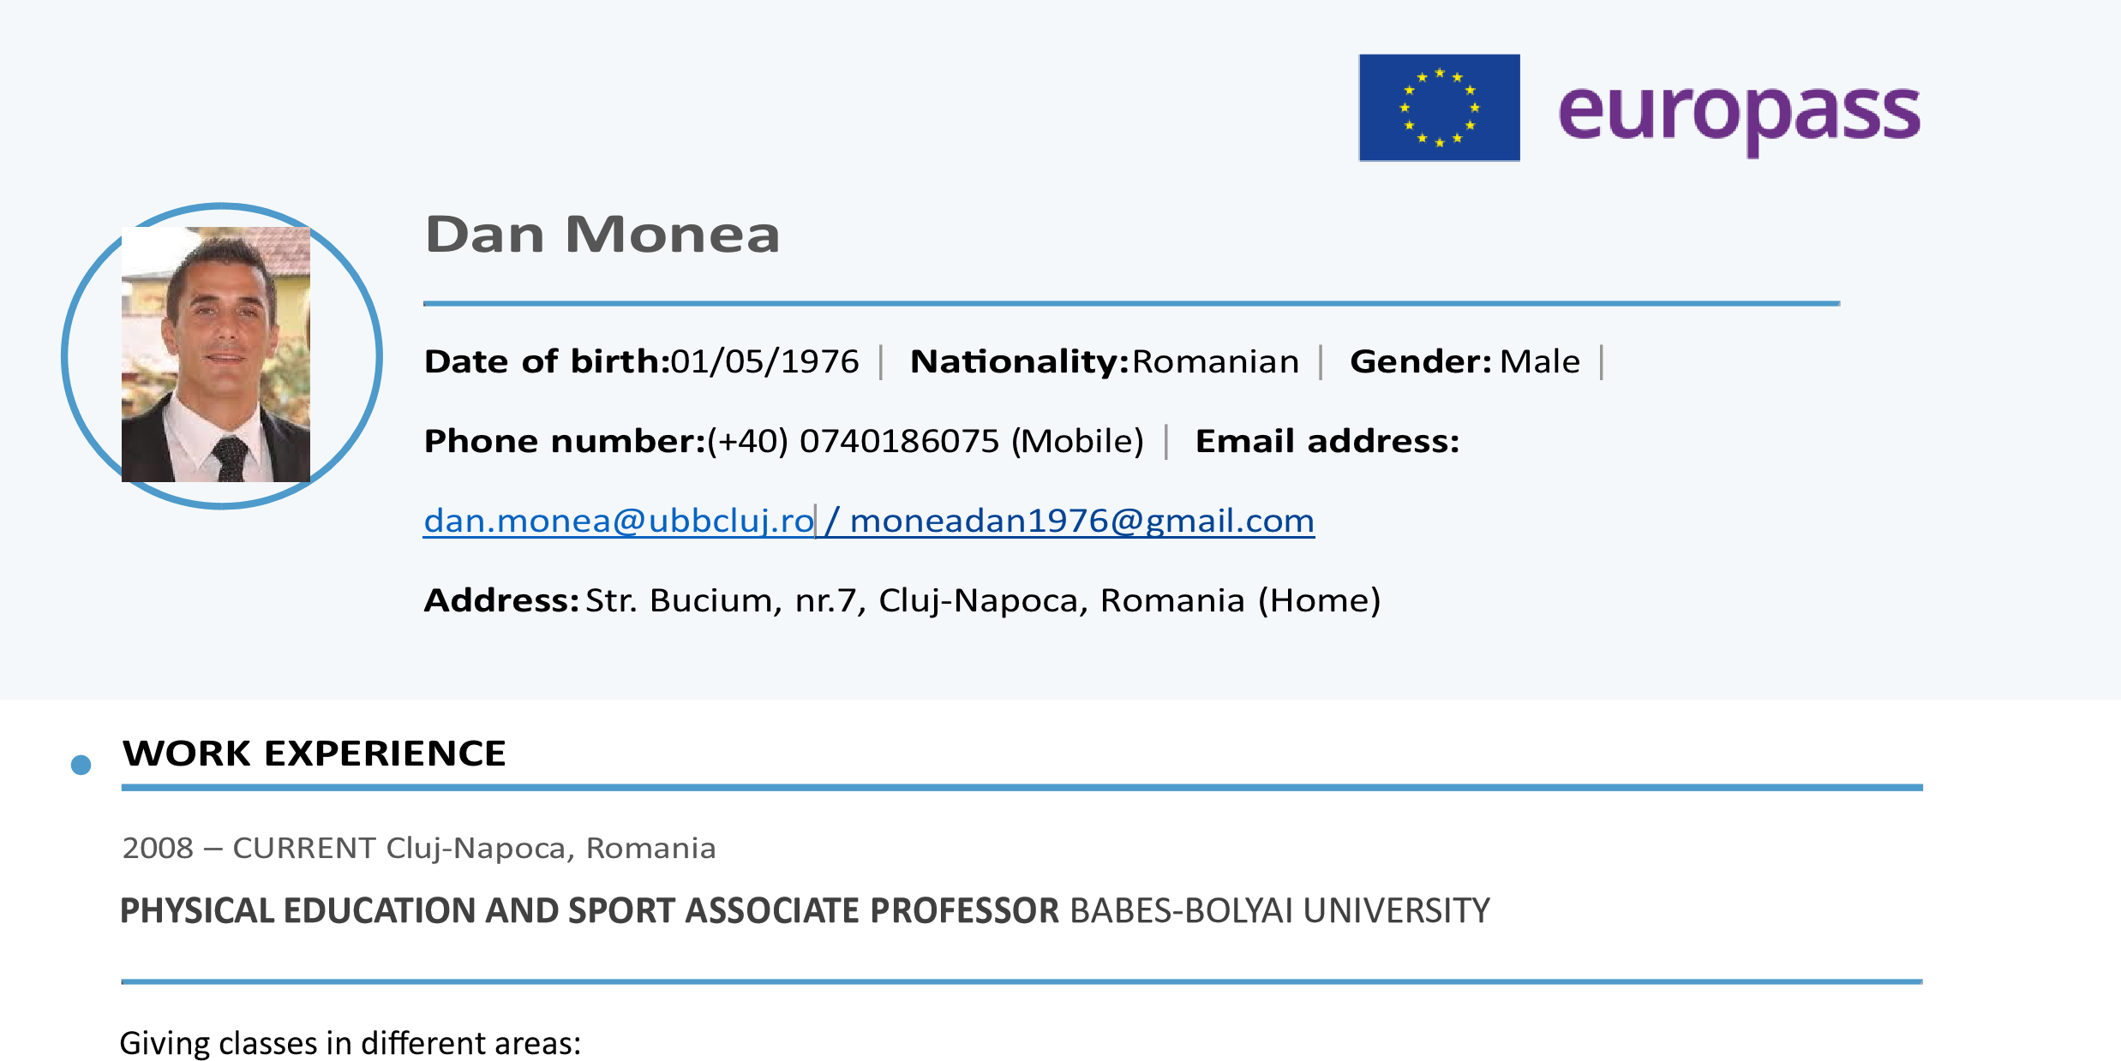
Teaching:
Interdisciplinary approach of Physical Education and Sport
Methodology of teaching football

01/09/1999 – 01/11/1999 Cluj-Napoca, Romania

UEFA Fitness Instructor for FOOTBALL REFEREE and NATIONAL Fitness Instructor

2010 – CURRENT Cluj-Napoca, Romania

PHD IN Physical Education and Sport Bucharest University

2000 – 2006 Bucharest, Romania

- / 2
Mother tongue(s):  language(s): | ROMANIAN Other  UNDERSTANDING |  | SPEAKING | WRITING
 | Listening | Reading | Spoken Spoken  production interaction
ENGLISH | C1 | C1 | C1 C1 | B2
FRENCH | - | - | - - | -
ITALIAN | - | - | - - | -
Levels: A1 and A2: Basic user; B1 and B2: Independent user; C1 and C2: Proficient user
DIGITAL SKILLS
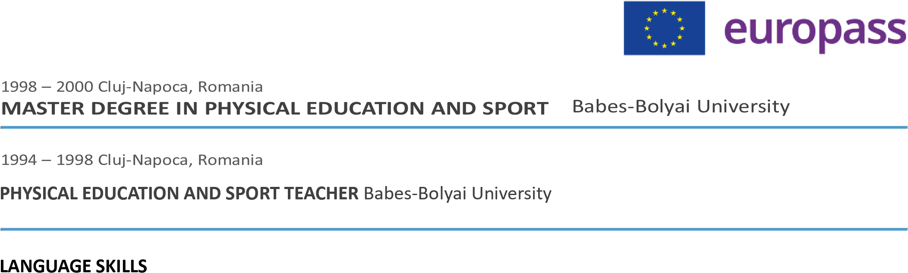
Microsoft Word Microsoft Excel Zoom Outlook Microsoft PowerPoint Skype. / 2

